Quiz
Decisions, Decisions…
Name:_________________________ Period:___ Date:________ Score:_____/40

- (2 pts.) For an Obstacle Detection program, what does the Switch-Loop do, and how does it do this?
- (2 pts.) Besides distance, what are other ways to control a Line Follower’s Switch-Loop?
- (2 pts.) Explain the role of the Switch Block in a Line Follower’s Switch-Loop.

- (4 pts.) Why doesn't this program work for Obstacle Detection?

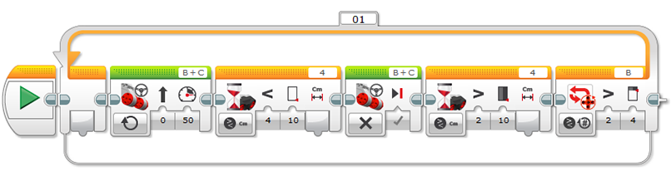

- (4 pts.) Ziffle writes this straight line Obstacle Detection program. What happens when the program is run? What does Ziffle need to do to improve it? Why?
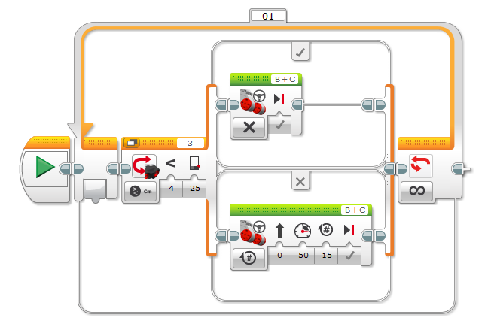

- (4 pts.) Ziffle wants this program to run all night. How long will it run? Why?
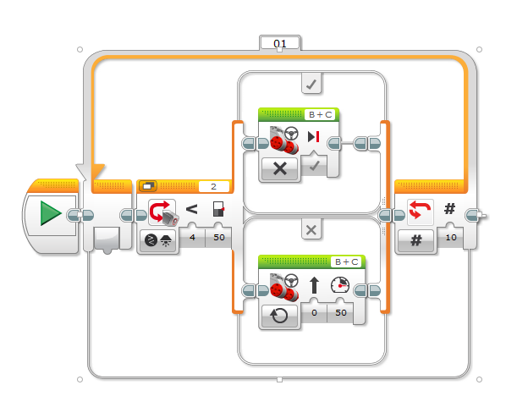
- (4 pts) Ziffle must make 4 modifications to make this line follower work…what modifications need to be made?
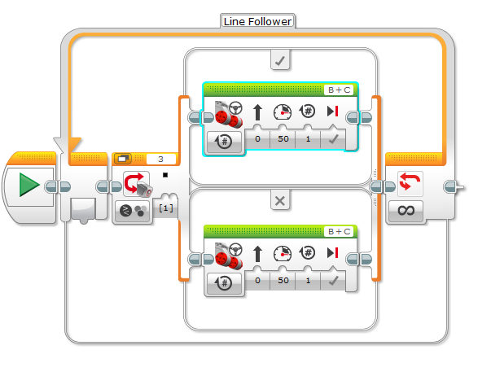

- (2 pts) What is multitasking?
- (2 pts) How can you run a program that has the robot looking for a black line, plays a song and writes to the screen, and lift a robotic arm all at the same time?
- (3 pts) Ziffle writes this program to have his robot go forward until it sees a black line and then turn, all the while constantly raising and lowering its robotic arm. Ziffle is disappointed (again). What is wrong with this program?
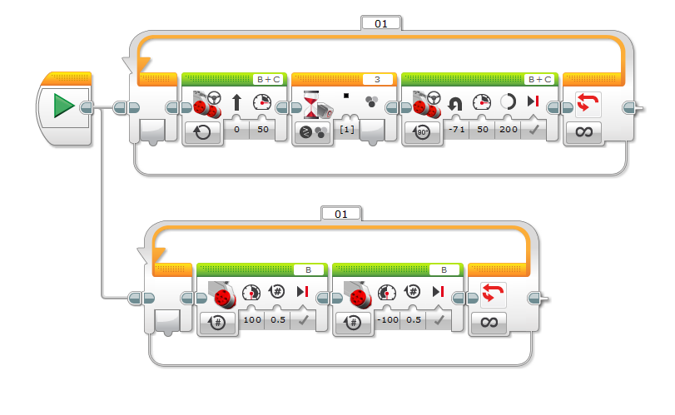
- (3 pts) Ziffle is having even more problems. He writes another program to stop a robots movement when the touch sensor is pressed. It’s not working. Why not?
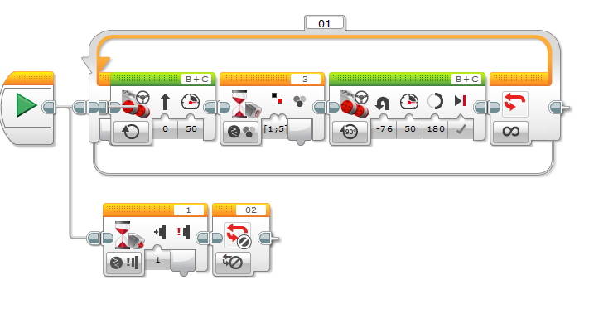
- (2 pts) What is a My Block?
- (1 pt) Give an example of why you might want to create a My Block.
- (1 pt) Where are My Blocks available once they are created?
- (4 pts.) Create Pseudocode describing the program in question 6.

